ZFP Tools Bugs

Text Boxes

When editing text in a text box anywhere in the tools attempting to type with the cursor position anywhere but the end of the string will cause the cursor to jump to the end after the first key press. Meaning to edit a name of something the entire text needs to be deleted and start again.

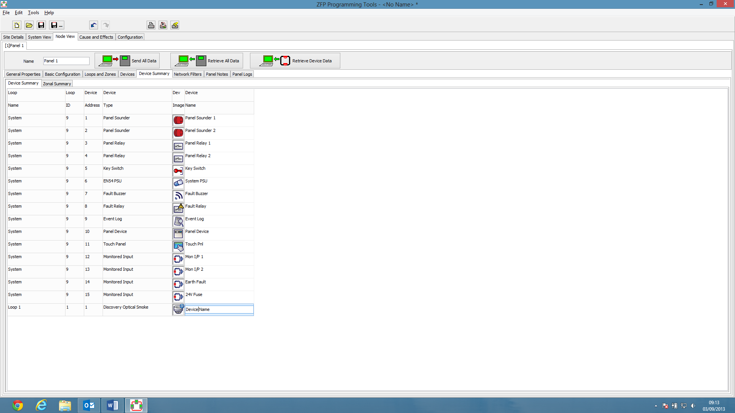
Moves here when you type

Remove All Supergroups in Output Supergroups

When creating an Output SuperGroup clicking the Remove All Button for the Supergroups list unticks all Normal Groups instead of all Supergroups.

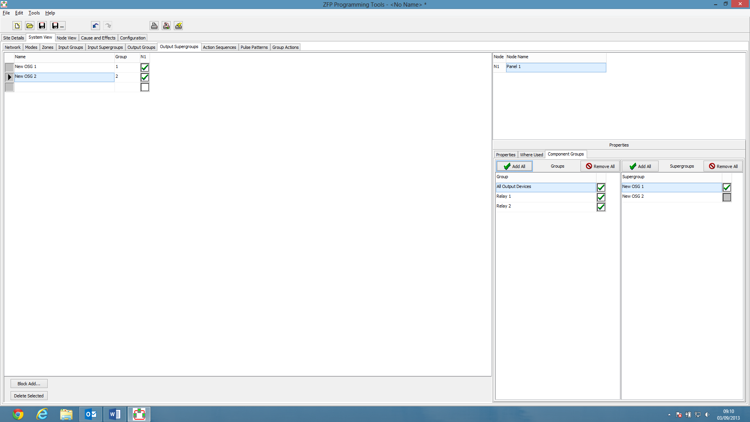
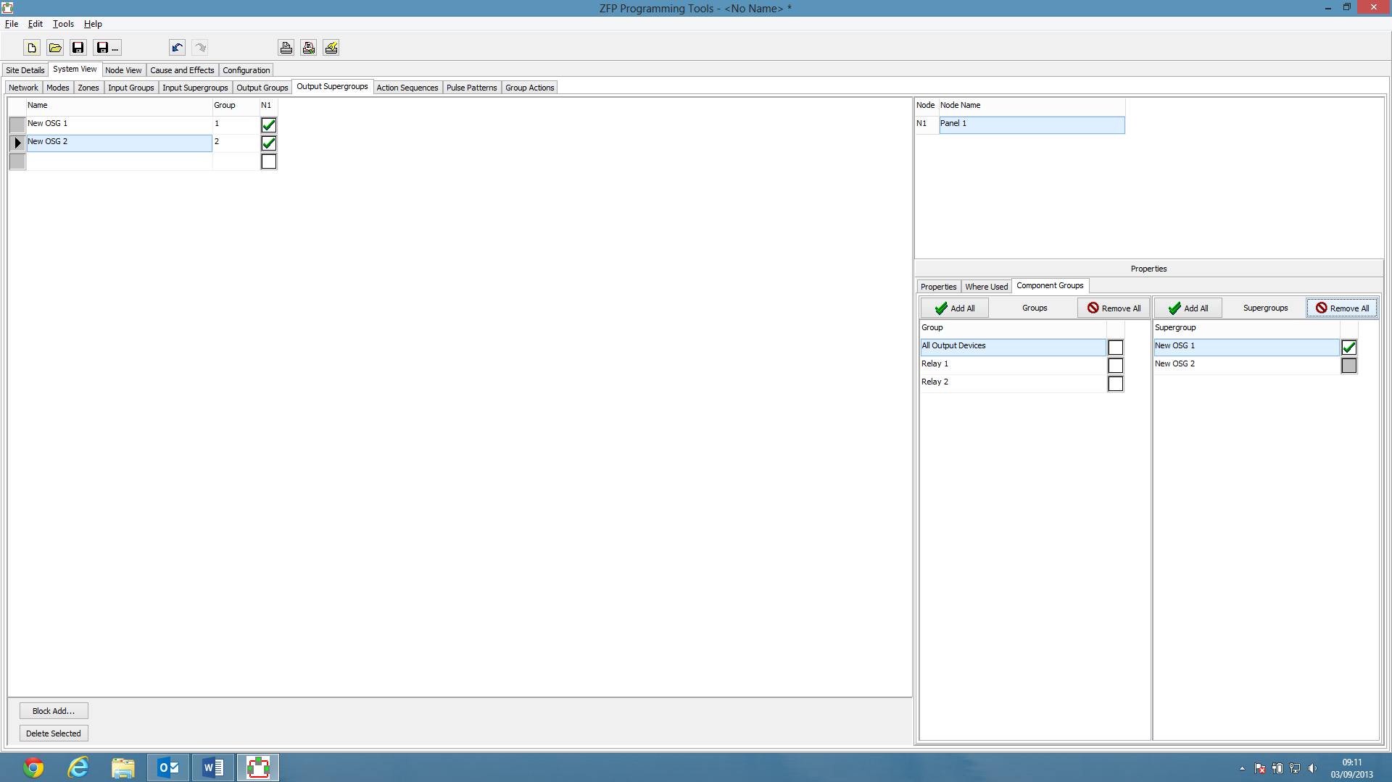

Parameter Field in Sequence Steps

If a step held previously an action without a parameter then when changed to need a parameter the field remains uneditable.

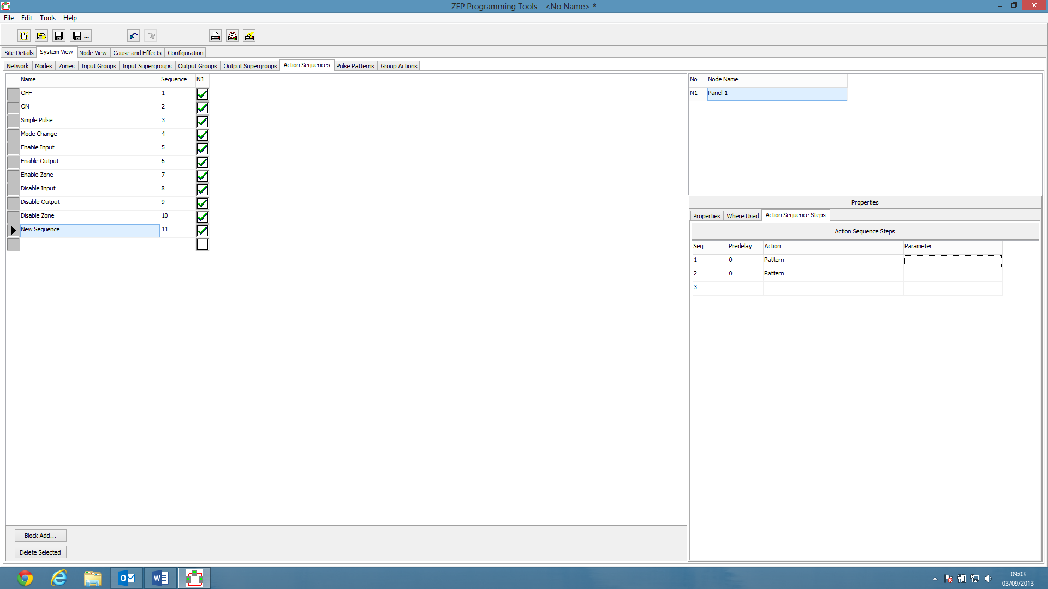

Volume Field in Group Actions

Volume should be able to contain values between 1 and 7. Should not exceed that or go negative.
Should be 0-255

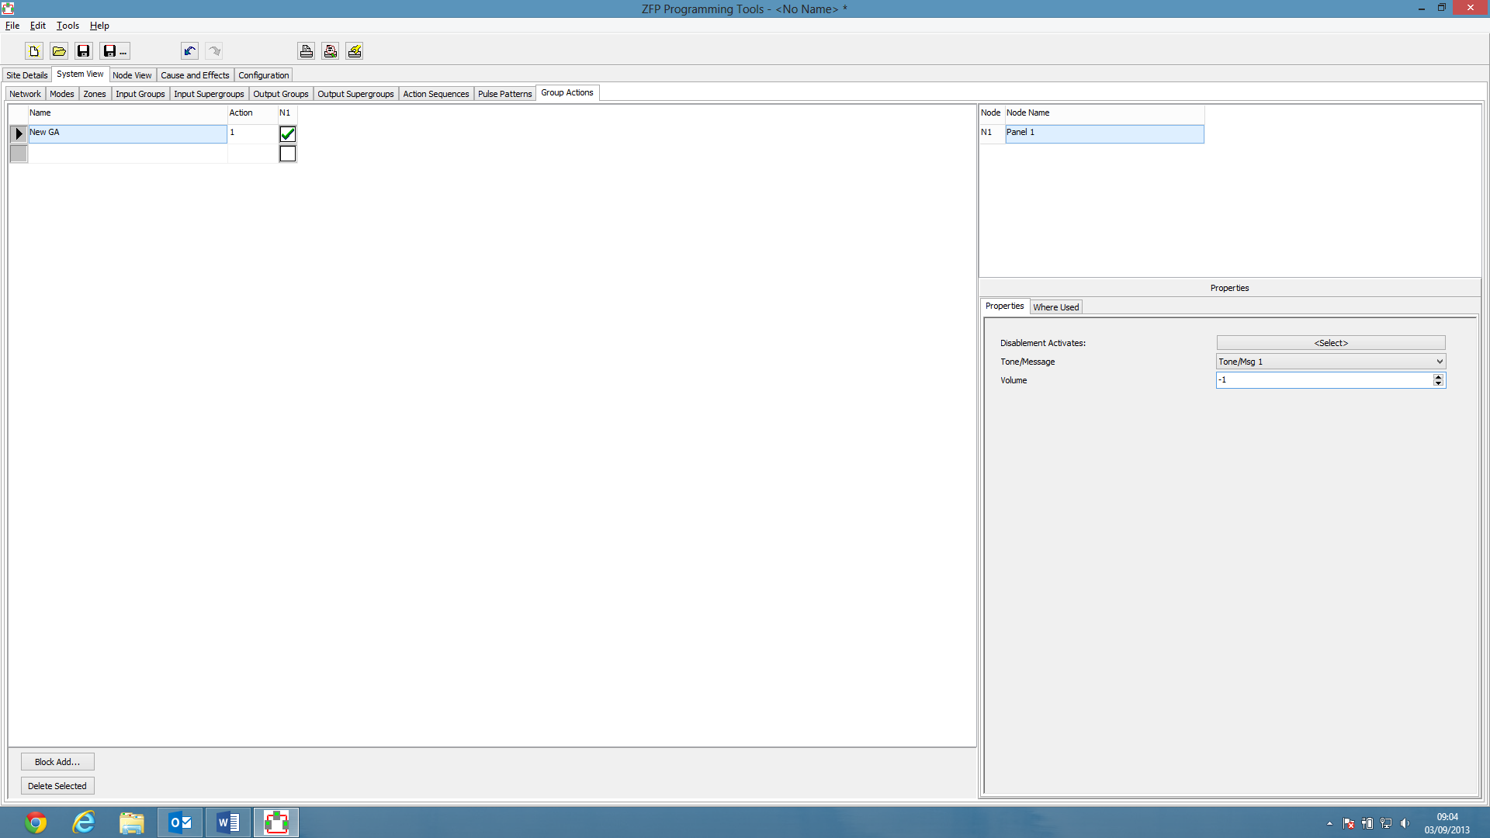
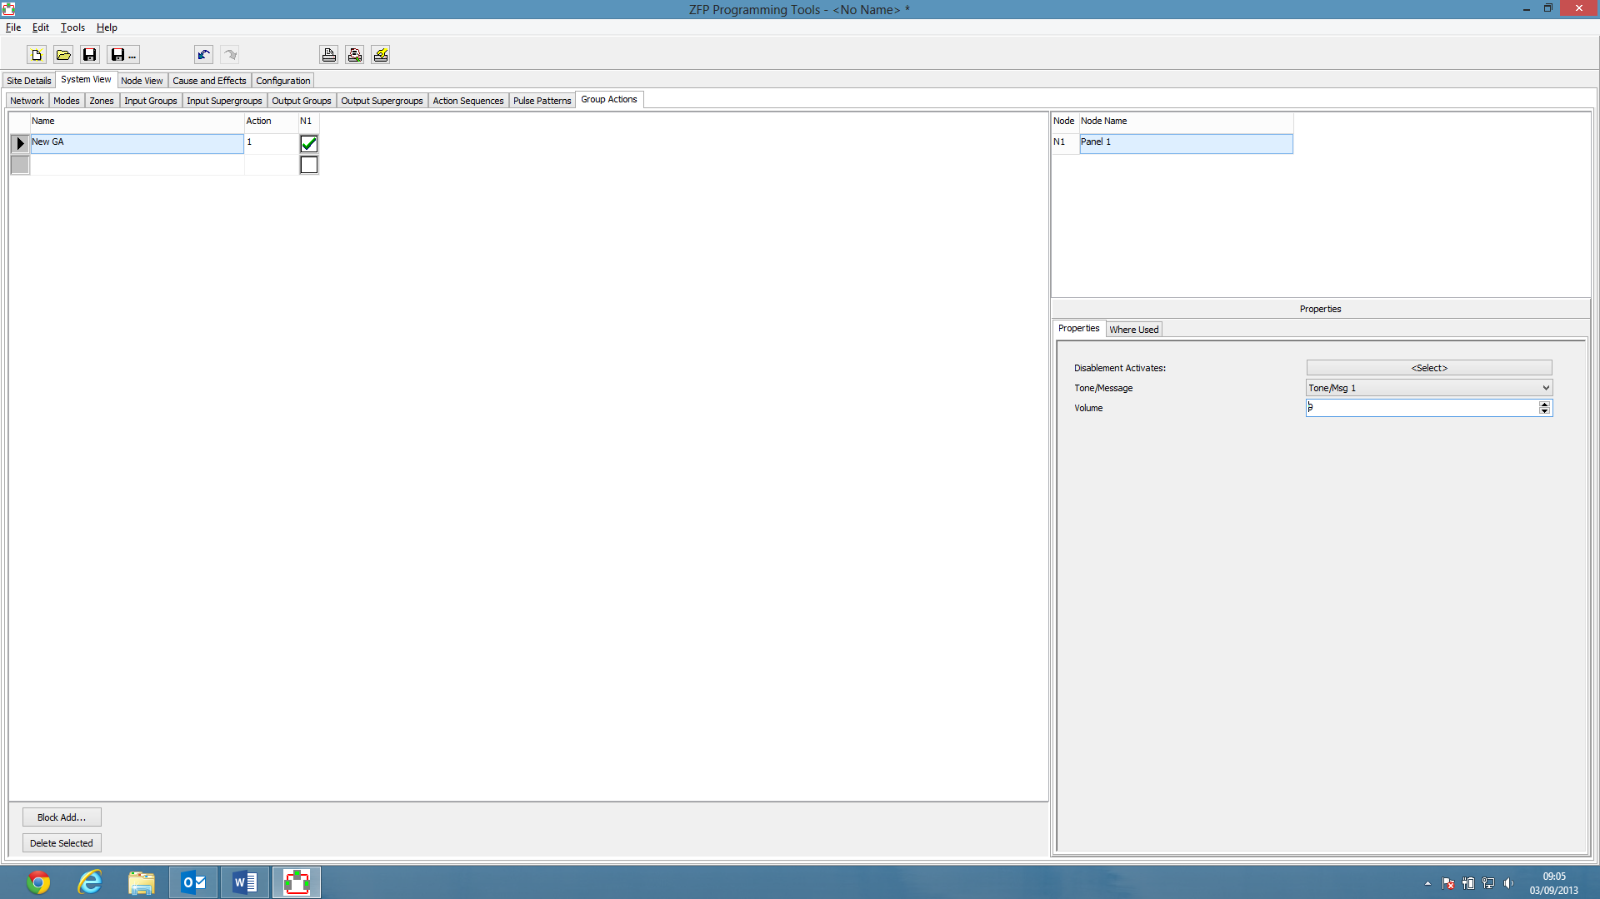

Panel Auto Dim

Should not be able to go negative.
Up and Down buttons work in multiples of 10 but the field allows for numbers not a multiple of 10.
Scrub

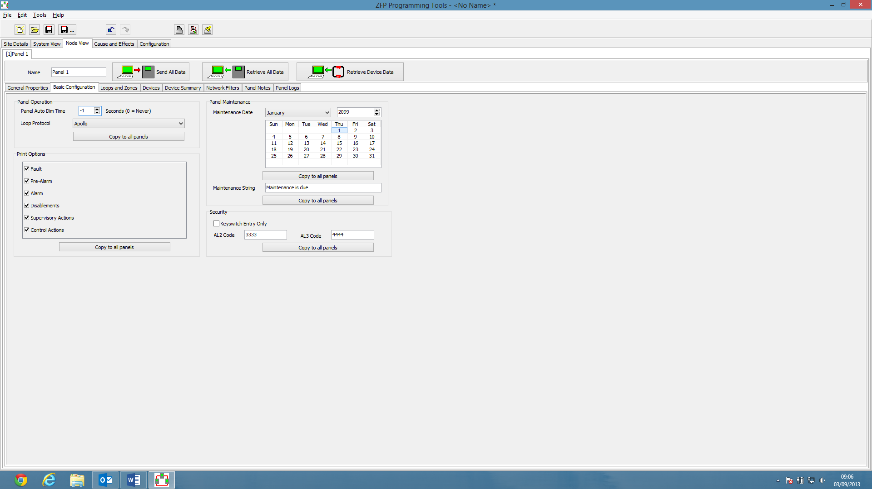

Zone IDs in Loops + Zones Tab

Should not be able to go negative or above 200.

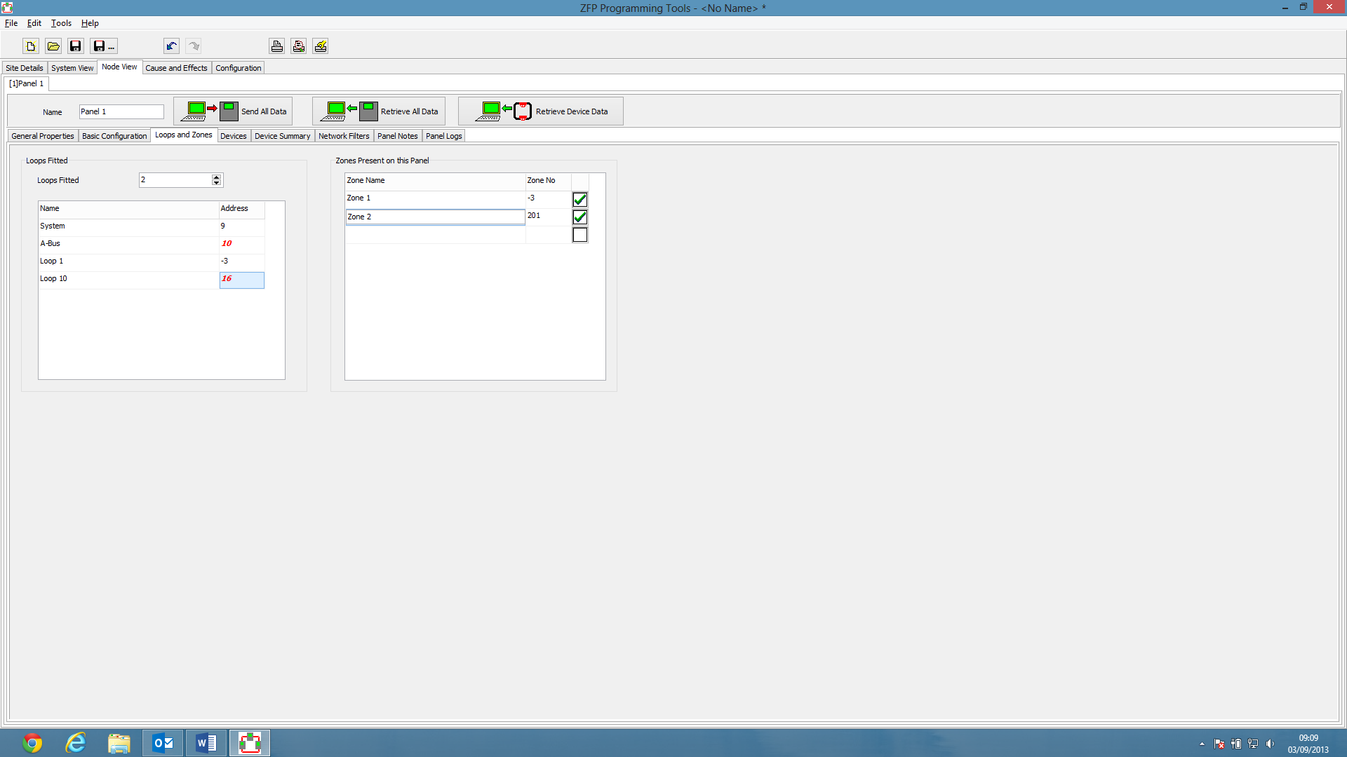

Loop IDs in Loops + Zones Tab

For Loops 1-8 the Address should only allow values 1-8, should not go negative or exceed that.
Should the Address Field be editable at all?

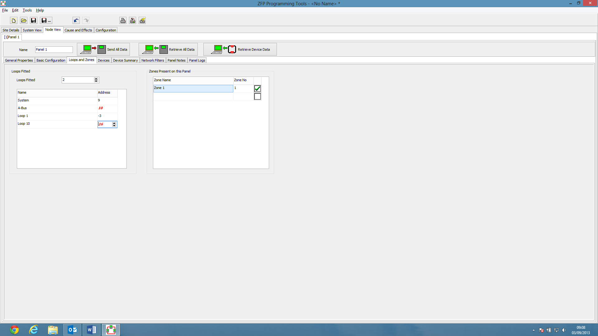

Suggestion

In Device Summary pressing the Return Key will select the next field immediately below the current field. Can this be replicated in similar places, i.e Entirety of the System View Tab + Loops and Zones Tab?

